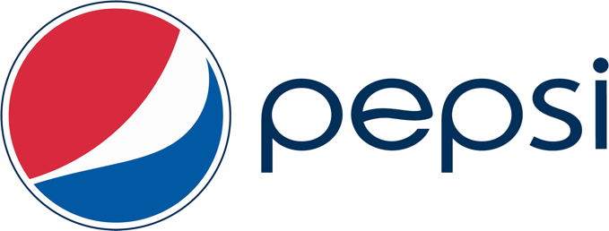

**UO Pepsi Events Challenge**

## The UO Pepsi Events Challenge will support spring, summer, and fall 2019 campus-wide student programming. One-time, cash sponsorships ($100–$1000) are available on a competitive basis to any organized UO student group (ASUO, EMU, CSI, academic department or auxiliary unit)

**Sponsorship Guidelines**

• Any cultural or educational event will be considered

• Events must be held on campus during 2019 spring, summer or fall terms

• Events must be open to the campus community

• Fundraising events are eligible, but raised funds must benefit a UO program or local

(Eugene-Springfield) nonprofit organization.

• We will only accept one application per student group

• All funded groups must agree to submit a signed award contract and post-event report

**Allowable Expenses**

• Event catering (UO Campus Catering or EMU food vendors only)

• Campus space rental and associated service fees (space set-up, tech services, equipment, etc.)

*Please note, no other event expenses will be considered

**Timeline**

**Proposal Submittal Deadline:** 5:00 p.m. on Wednesday, March 13, 2019

**Funding Notification:** by March 22, 2019

**For Event Occurring:** spring, summer, or fall 2019

*Please note, there is only one submission deadline. Late requests will not be considered.

**Before you begin**

• Read sponsorship guidelines

• Remember, your application will be reviewed by a team of students and staff who may not be familiar with your group or event, so please be clear, detailed, and concise.

• Neatness counts. Use spell-check, proofread, and ask a friend to read your final draft.

**Submittal Information**

• You may duplicate the application form, but please do not exceed space limitations

• Do not send attachments (photos, letters of support etc.)

• Send completed application to: Mary Farrington, EMU External Support and Relations Manager, at [farring@uoregon.edu](mailto:farring@uoregon.edu)

**•** Submit by 5:00 p.m. on Wednesday, March 13, 2019.

**Incomplete or late submittals will not be considered.**

**Application Checklist:**

_____event occurs on campus

_____funding is requested for an allowable expense

_____proposal includes student representative and authorized staff contact information

**Questions?** Contact Mary Farrington, EMU External Support and Relations Manager, at [farring@uoregon.edu](mailto:farring@uoregon.edu) or 541-346-6090.

**UO Pepsi Events Challenge 2019 Application**

**A. Student Group Information**

Application Date:

UO Student Group Name:

Total Group Membership:

Student Representative Name:

Email: Phone:

*Required

Under which program (ASUO, EMU, UO, CSI, academic department, or auxiliary unit) is the student group recognized?

*Required

Student Group or UO Department/Program Index #:

*Required

Authorized staff (non-student) contact (name, email, and phone)

Sponsorship recipients will be notified by email, and awards will be transferred to the indicated index in Banner.

**B. Project Information**

Event Title:

Event Date: ______________ _______________ ______________

Spring 2019 Summer 2019 Fall 2019

Event Location:

Requested Sponsorship Amount ($100–$1000):

**C. Project Description**

1.Briefly describe the mission and activities of your student organization.

2. Provide a brief description, goals, and objectives of the proposed event.

3. Describe the people, organizations, or groups expected to attend. How many people will this event serve?

4. How are students involved in planning and managing this event?

5. How, specifically, will sponsorship funds be used?

6. Describe your advertising plan. How will Pepsi be recognized in event promotions?

7. How will you evaluate the success of your project?

**D. Project Budget**

Please list all event costs and all sources of event support (indicate whether support is committed or anticipated). **Total project costs must equal total event support**. In addition, please provide the source of each cost estimate (see sample budget below)

**SAMPLE Budget :**

**Event Costs**

Catering 2 fresh fruit trays at $50 $100

100 muffins at $1.50 $150

Coffee $25 per gallon on x 4 $100 Juice $30 per gallon x 4 $120

Venue Fee EMU Lillis Room 1 hr. at $500 $500

Equipment Fee 1 microphone $ 30

Speaker Fee $500 honorarium x 1 $500

**Total Event Cost $1500**

(**This is a sample only. Please contact vendors for actual costs)**

**Event Support**

Pepsi Events Challenge (anticipated) $1000

ASUO Program Support (confirmed) $ 500

**Total Project Support $1500**

**Total Event Costs ($1500) = Total Event Support ($1500)**

**Cost Estimate Sources**

Catering: UO Campus Catering

Space and Equipment Rental: EMU Scheduling and Event Services, scheduling.uoregon.edu

Speaker Booking Agent [speakerworld@estimates.com](mailto:speakerworld@estimates.com)

**\*\*Enter your actual Event Budget Details below. Provide one extra page if needed**

**UO Pepsi Events Challenge**

**Event Budget Detail**

**Group Name:**

**Event Title:**

**Event Costs:**

**Event Support:**

**Total Event Costs $___________ = Total Event Support $____________**

**Cost Estimate Sources:**