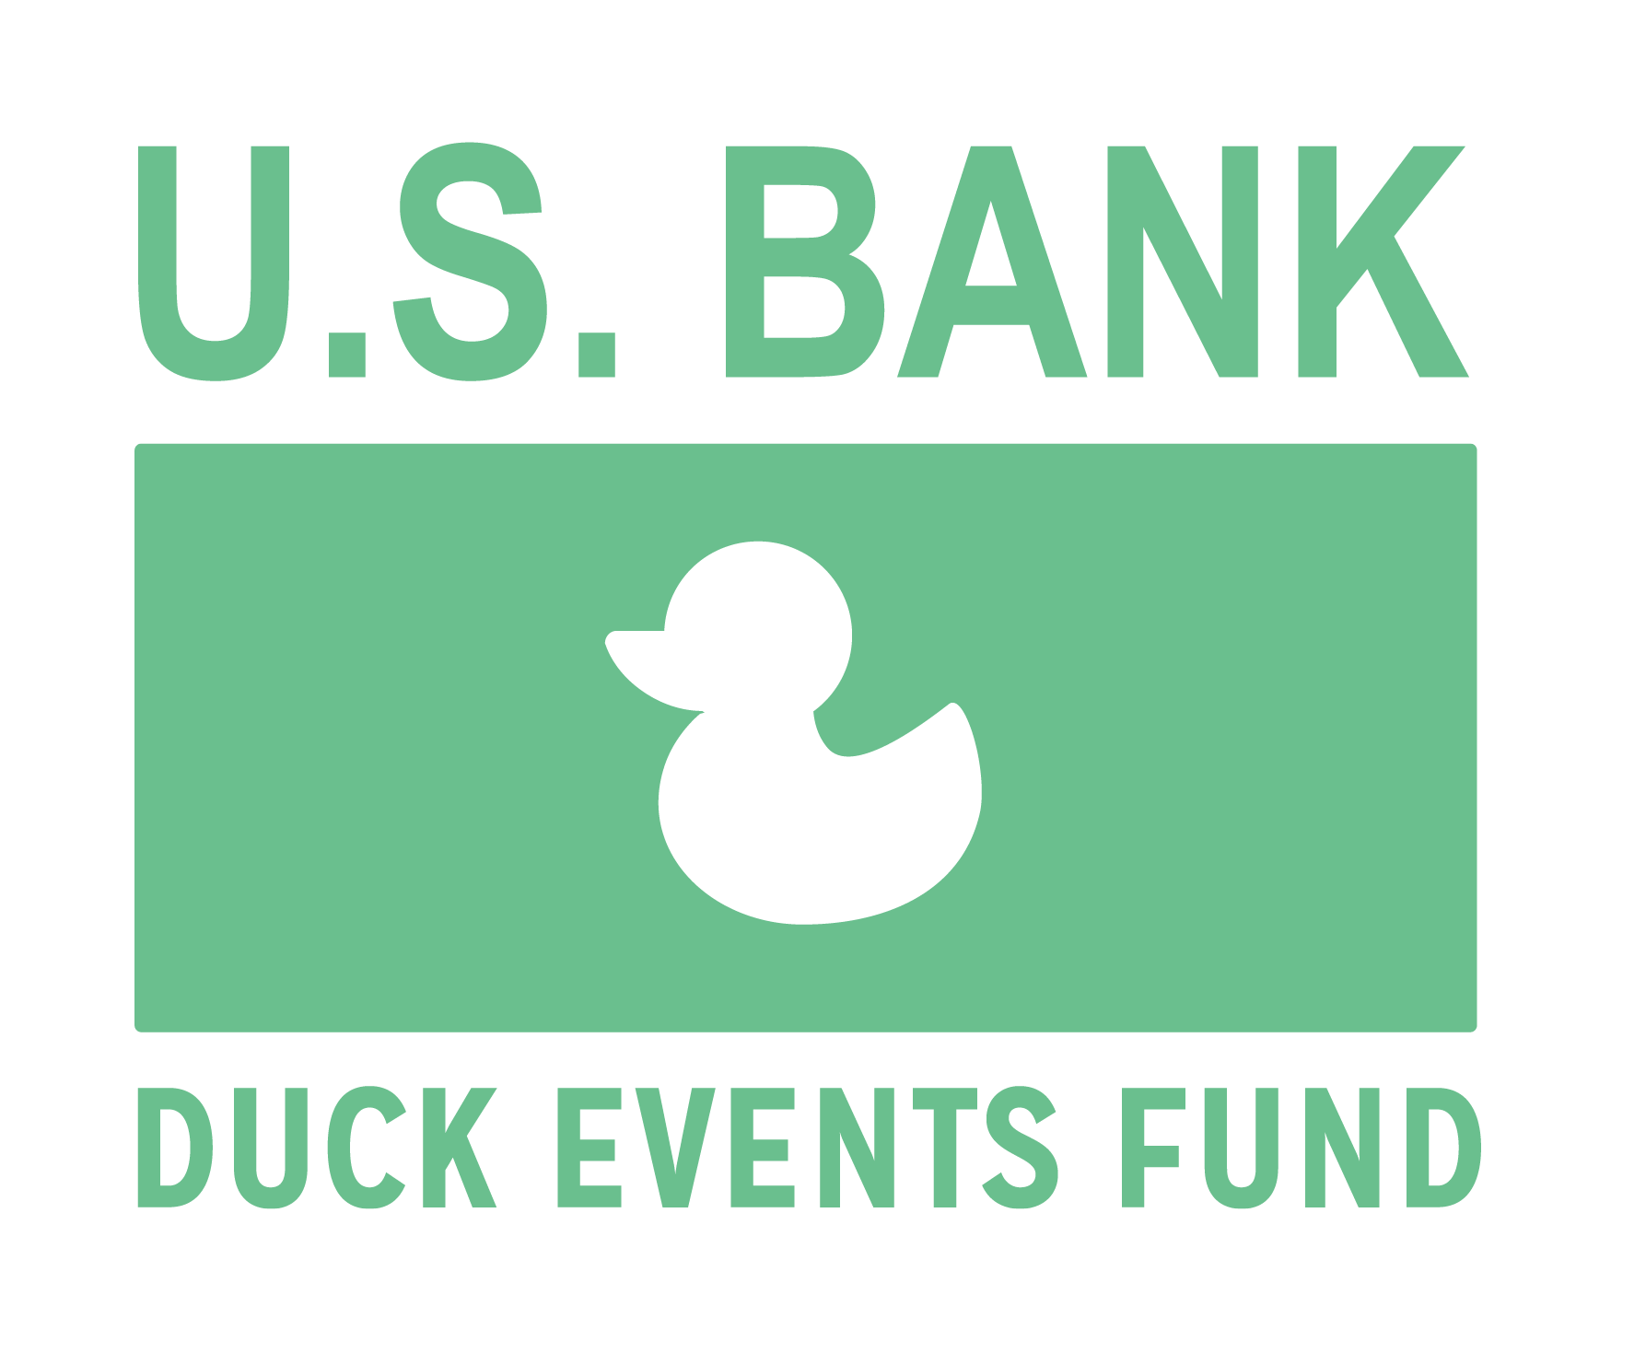

The U.S. Bank Duck Events Fund supports campus-wide student programming. One-time awards ($100 - $1000) are available Fall, Winter, and Spring terms on a competitive basis to any organized UO student group (ASUO, EMU, academic department, or auxiliary unit). All cultural and educational events are considered.

Sponsor Code of Ethics

• Uncompromising Integrity: doing the "right thing" even when circumstances make it difficult
• Respect: treating one another with respect and dignity
• Responsibility: taking accountability for ethical decisions and actions • Good Citizenship: contributing to the wellbeing of our communities

U.S. Bank Duck Events Fund Guidelines

• Events must be held on campus
• Events must be open to the campus community
• The U.S Bank Duck Events Fund must be recognized in all event promotions
• Awarded funds may only be applied to the event and activity described in the proposal
• Fundraising events are eligible, but raised funds must benefit a UO program or local (Eugene/Springfield) nonprofit organization.

• All funded groups will submit a signed award contract and post-event report
• You may submit multiple proposals including requests for previously funded events. However, new or different events may receive higher consideration. Please do not count on Duck Event Fund support for ongoing or repeat project funding.

Allowable / Ineligible Expenses

Duck Event Funds CAN support Duck Event Funds CANNOT Support
• Facility /Equipment Rental • Catering/ Refreshments / Receptions
• Advertising Costs • Equipment Purchases
• Speaker / Performer fees & travel costs • Monetary Prizes
• Printing • Limited Invitation Events
• Postage • Personnel
• Supplies • Expenses incurred before award date

Deadlines
Please submit no earlier than one term before scheduled event

Proposal Submittal Deadline Funding Notification For Event Occurring
5:00 p.m. Wednesday 11/29/17 by 12/8/17 Winter Term 2018
5:00 p.m. Wednesday 3/14/18 by 3/23/18 Spring Term 2018
5:00 p.m. Wednesday 6/6/18 by 6/15/18 Fall Term 2018

Before you begin

• Read grant guidelines, application, and previously funded proposal (pg. 7-10)
• Remember, DEF reviewers are busy students and staff who read multiple proposals. They
may not be familiar with your group or event, so please be clear and detailed, yet concise.
• Neatness counts. Use spell-check, proofread, and ask a friend to read your final draft.

Submittal Information

• You may duplicate the application form but please do not exceed space limitations
• Do not send attachments (i.e. photos, letters of support etc.)
• Send completed application to: Mary Farrington, EMU Grant Writer farring@uoregon.edu
• Submit by designated deadline. Incomplete or late submittals will not be considered.

Application Checklist:
_____event occurs on campus
_____funding is requested for an allowable expense
_____proposal includes student representative and authorized staff contact information
_____proposal is submitted no earlier than one term before scheduled event

Questions? contact Mary Farrington, EMU Grant Writer farring@uoregon.edu, 541-346-6090

U.S. Bank Duck Events Fund
2017-2018 Application

A. Student Group Information

Application Date:

UO Student Group Name:

Total Group Membership:

Student Representative:

Student Name Email

Under which program (ASUO, EMU, UO academic department, or auxiliary unit) is the student group recognized?

Student Group or UO Department/Program Index #:

Authorized staff (non-student) contact (name, e-mail, and phone)

Sponsorship recipients will be notified by e-mail and awards will be transferred to the indicated index in Banner. All funded groups will submit a post-event report.

If awarded, we will spend sponsorship money for the purpose stated in this proposal.
We understand that all expenditures are in compliance with stated guidelines and any unused sponsorship money will be refunded to the Duck Events Fund.

Applicant Signature:
Name Date

B. Project Information

Event Title:

Event Date:

Event Location:

Requested Sponsorship Amount ($100 - $1000):

C. Project Description

1.Breifly describe the mission and activities of your student organization.

2. Provide a brief description, goals and objectives of the proposed event.

3. Will requested funds support a one-time expense (e.g. one-time venue rental) or
reoccurring item/action (e.g. purchase of a banner used at monthly events.)

4. Describe the people, organizations or groups expected to attend. How many people will this project serve?

5. How are students involved in planning and managing this event?

6. How, specifically, will sponsorship funds be used?

7. Describe your advertising plan. How will the Duck Events Fund be recognized in event promotions?

8. How will you evaluate the success of your project?

D. Project Budget

Please list all event costs and all sources of event support (indicate whether support is committed or anticipated). Total project costs must equal total event support. In addition, please provide the source of each cost estimate (see sample budget below)

Sample Budget

Event Costs
Speaker Fee 1 hr @ $300 $ 300
Advertising 3 Oregon Daily Emerald Ads @ $150 $ 450
Venue Rental 2 hours EMU Ballroom @ $500 $1000
Total Event Cost $1750
(This is a sample only. Please contact vendors for actual costs)

Event Support
Duck Event Sponsorship Fund (anticipated) $ 750
Event Ticket Sales (anticipated) $ 500
ASUO Program Support (confirmed) $ 500
Total Project Support $1750

Total Event Costs ($1750) = Total Event Support ($1750)

Cost Estimate Sources
Speaker Booking Agent speakerworld@estimates.com
Oregon Daily Emerald ode@uoregon.edu
Ballroom Rental: EMU Scheduling and Event Services http://scheduling.uoregon.edu/

**Enter Event Budget Details on following page. Provide one extra page if needed

Duck Events Fund
UO Student Group Name:

Event Budget Detail (enter detail below. Provide one additional page if needed)

Event Costs

Event Support

Total Event Costs $___________ = Total Event Support $____________

Cost Estimate Sources:

June 2018

* Example of recently funded proposal

U.S. Bank Duck Events Fund Application

A. Student Group Information

Application Date: March 1, 2014

UO Student Group Name: Grebes (Graduate Evolutionary Biology and Ecology Students)

Total Group Membership: 20-30 (fluctuates by term)

Student Representative:
Student Name Jane Smith Email janesmith@uoregon.edu

Under which program (ASUO, EMU, UO academic department, or auxiliary unit) is the student group recognized? ASUO

Student Group or UO Department/Program Index #: OS 1111

Authorized staff contact (name, e-mail, and phone)
Dr. John Doe, Faculty, UO Science Dept. johndoe@uoregon.edu 541-346-0000

Sponsorship recipients will be notified by e-mail and awards will be transferred to the indicated index in Banner. All funded groups will submit a post-event report.

If awarded, we will spend sponsorship money for the purpose stated in this proposal.
We understand that all expenditures are in compliance with stated guidelines and any unused sponsorship money will be refunded to the Duck Events Fund

Applicant Signature: Jane Smith March 1,2014
*typed or signed and scanned ok Name Date

B. Project Information

Event Title: Astrobiology: Life at the Limits

Event Date: April 30th, May 7th & May 28th, 2014 Event Location: UO Lillis #282

Requested Sponsorship Amount ($100 - $1000): $750

C. Project Description

1.Breifly describe the mission and activities of your student organization.

Our program has 4 major goals that we achieve through the activities of our student organization. (1) We enhance graduate student communication and relationships with other graduate students, undergraduates, Biology department faculty, and the GTFF by hosting both a Winter Retreat and Fall “Welcome Back” BBQ. (2) We encourage academic leadership among biology graduate students by hosting speakers and organization for our Spring Seminar Series, subsidizing student research and travel, offering workshops to advise undergraduates interested in graduate school, and offering scholarships to those undergraduates interested in mentored research of their own. (3) We provide professional development seminars for the graduate students that would not otherwise be available. (4) We engage with the larger university and Eugene-Springfield communities by organizing free and public Spring Seminar Series aimed at communicating the meaning and significance of scientific breakthroughs to a general audience.

2. Provide a brief description, goals and objects of the proposed event.

Although scientific breakthroughs are communicated to the public on a daily basis, the true meanings of these breakthroughs are often obscured by misinterpretation through the media lens and lack of context for the intended audience. The free and public Spring Seminar Series features leading scientists communicating scientific breakthroughs to a mixed audience of campus and community members. In 2012, we held a very successful pubic lecture series featuring three prominent scientists from the UO. Each talk was attended by over 250 people, and video feed was made available through the UO Channel.

This year’s Spring Seminar Series theme is Astrobiology: Life at the Limits. We have three internationally known scientists scheduled for tree separate days in Spring of 2014. Lynn Rothschild is speaking Wednesday, April 30th, Chris McKay is speaking Wednesday May 7th, and Maggie Turnbull is slated for Wednesday, May 28th. We are prepared in terms of internal organization and level of commitment to support these programs and we will continue to seek additional departmental funding and fund-raising funds to supplement our request from the ASUO.

3. Will requested funds support a one-time expense (e.g.one-time venue rental) or reoccurring item/action (e.g. purchase of a banner used at monthly events).

Requested funds will support one-time expenses for this year’s (2014) Spring Seminar Series, including but not limited to, facility and equipment rental, speaker travel fees, and advertising/printing costs.

4. Describe the people, organizations or groups expected to attend. How many people will this project serve?

Both members of the campus community and the wider Eugene-Springfield community have historically attended; we therefore expect 200-250 people at each event, for a total of 600-700. In addition, the talks will be recorded and archived on the UO channel for perpetuity, guaranteeing continued viewership to the general public for free.

5. How are students involved in planning and managing this event?

Students are completely in charge of this event. The Grebes’ membership votes on nearly all aspects of the event including theme and artwork, with a voluntary committee in charge of logistical tasks such as travel and event reservations, as well as advertising.

6. How, specifically, will sponsorship funds be used?

Sponsorship funds will be used to defray the cost of advertising and printing, as those constitute of 50% of our budget for this event. (See advertising details in #7).

7. Describe your advertising plan. How will the Duck Events Fund be recognized in event promotions?

If funded, a Duck Events Fund logo will be added to all advertising. This will be used for posters to be distributed around campus and the wider community, utilizing Grebes’ volunteers and WOW Hall’s poster distribution service. In addition, we would like to fundraise enough money to place advertisements in issues of the Emerald and the Eugene Weekly.

AAA Printing: color posters, b&w handbills for each seminar = $168
WOW Hall poster distribution = $72

8. How will you evaluate the success of your project?

The success of our project will largely be evaluated by attendance and feedback from the audience. Grebes’ volunteers will be used to take attendance and collect this feedback at each event.

D. Project Budget

Please list all event costs and all sources of event support (indicate whether support is committed or anticipated). Total project costs must equal total event support. In addition, please provide the source of each cost estimate (see sample budget below)

Duck Events Fund: Project Budget

UO Student Group Name: Grebes
Event Title: Spring Seminar Series: Astrobiology: Life at the Limits

Budget Detail

Event Costs
Speaker Fees $250 honorarium x 1 $ 250
Venue /Equipment Rental Lillis Room #282: $400 x 2 hrs. $ 800
Speaker Travel / Lodging $906 x 3 speakers $2718
Printing Color Posters: 300 – 11x17” @.50 $ 150
Black & White Handbills: 300 @ . 08 $ 18
Distribution WOW Hall service $ 71
Advertising Emerald Full page for 7 days $ 867
Eugene Weekly; ¼ pg @ $598 x 4 days $2392
Total Event Costs $7266

Event Support
ASUO Program Support (confirmed) $2516
Duck Events Fund (anticipated) $ 750
Institute of Ecology and Evolution Foundation (confirmed) $1500
Department of Biology (confirmed) $ 500
Oregon Humanities Center (confirmed) $1000
College of Arts and Sciences (confirmed) $1000
Total Event Support $7266

Total Event Costs $7266 = Total Event Support $7266

Cost Estimate Sources
University of Oregon Event Services (scudule@uoregon.edu)
Excelsior Inn/Secret Garden Hotel (541)342-6963
AAA Printing: http://aaa.uoregon.edu/output/prices
WOW Hall poster distribution: http://www.wowhall.org/rental-information
Oregon Daily Emerald: breynolds@dailyemerald.com
Eugene Weekly: Sales 541-484-0519

